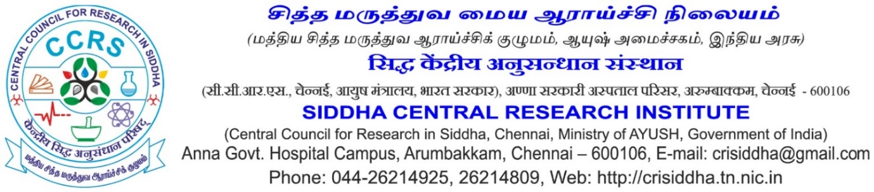
Application for the Post of Research Associate (Siddha)
Affix a recent
Passport
size color
photograph

Name in full (in CAPITAL letters) (Enter the name as given in Matric/SSLC Certificate. If there is any change in the name, including initials, attach documentary proof)
Father’s/Husband’s name
Whether belongs to SC/ST/OBC/UR (Enclose a copy of the certificate from the Competent Authority, if applicable)
Are you a physically challenged person?
Address in CAPITAL letter with PIN code
Permanent:

Correspondence:

E-mail Id:

Mobile/landline phone No.:

Date of birth (as entered in Matric/SSLC/HSC):

P.T.O
--:: 2 ::--
9. Educational Qualifications: (Attach self – attested copies of relevant documents)
Examination Passed | Name of the Degree/ Diploma | Name of the Board /University Division | Grade obtained | Subject(s) (major) / Specialization | Distinction, if any
10th
10+2 or equivalent
Bachelor’s degree
Master’s
degree
PhD.
Any other qualifications
10. Experience: (Attach self-attested copies of relevant documents)
Post Held | Name of the Institution/Organization | Duration  From………To…………. | Scale of Pay | Nature of duties | Reasons for quitting the service
11. Publication Details (Siddha books/ Journals):- (Attach relevant copies)
12. Work/project related to Terminology based (Give details)
13. Any computer knowledge & skill and internet applications. (Give details)
14. Other information, if any: (Enclose separate sheet, if required)
DECLARATION
I declare that all the information provided in the application are true, complete and correct to the best of my knowledge and belief. I also fully understand that if at any stage, it is discovered that any attempt has been made by me to willfully conceal or misrepresent the facts, my candidature may be summarily rejected or employment terminated.
Place:  Date: | Signature of the Applicant

